Flight Price Prediction

Flight ticket prices hard to guess, it changes day by day it is very difficult to predict. Here we get prices of flight tickets for various airlines between the month of March and June of 2019 from various cities. In this project we build a machine learning model to predict the price of the fight ticket.
We begin our journey to loading data set into jupyter notebook. After looking at data we have 10683 Rows and 11 Columns. In columns there is Airline, Date of Journey, Source, Destination, Route, Departure Time, Arrival Time, Duration, Total Stops, Additional Info, Price information given. Let’s start analysis the data. We checking for null values we found only 2 null values in Route and Total Stops columns. There are not much null values so we drop those columns. We dig deeper and check duplicates and drop it.
Here we do features engineering. Convert Date of Journey Arrival Time features Departure Time into date time formats. Add Months column using date time library, similarly we add day columns. Next step we take to converting New Arrival Time and New Departure Time column into minutes we use lambda function.
Now we do analysis of features start with Airline. In Airline Company Jet Airways have highest no of flights.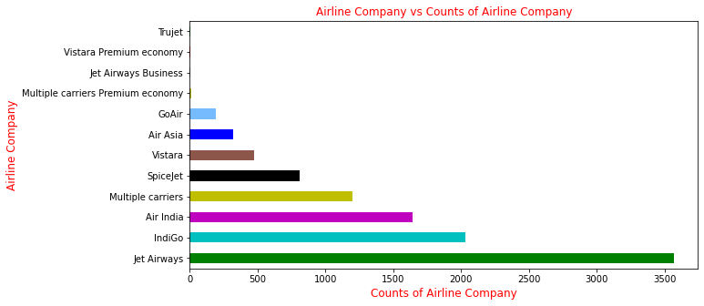
Compare to other Airline Company Jet Airways sell is highest.
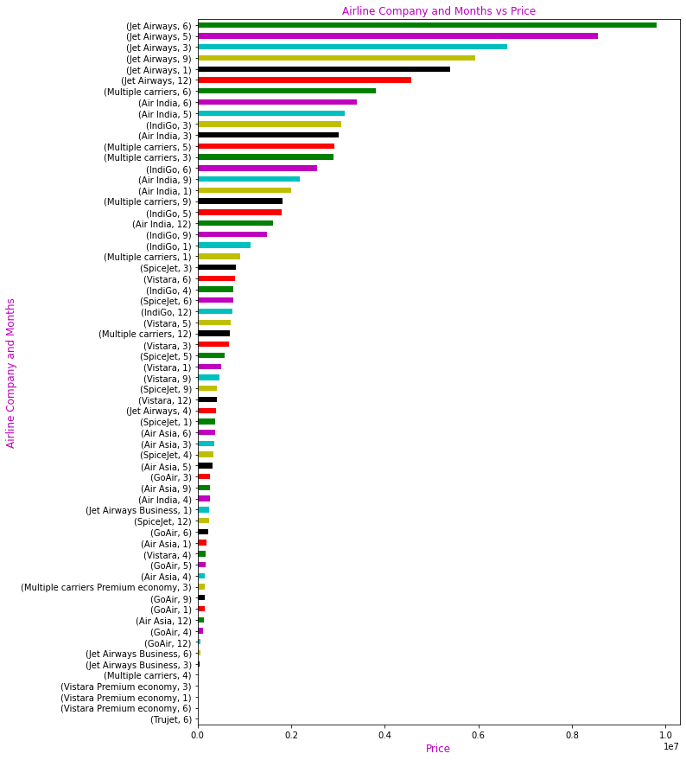
People travel more often from Delhi and price is also high Delhi to Cochin route.
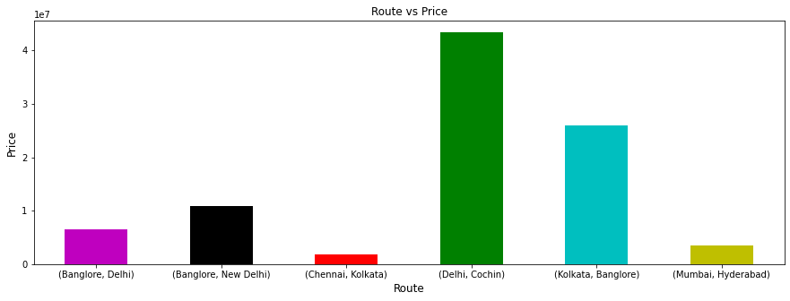
We do our analysis and observe people prefer take 1 stop flight other stops.

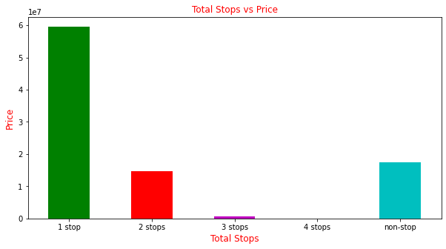
Analysis of duration features we found price increase respect to duration.
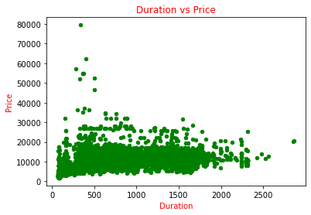
Here we have done analysis of data. Now we enter into preprocessing phase. In this phase first we delete unwanted column which is Date of Journey, Departure Time, Arrival Time, Duration columns. After dropping we check it deleted of not. Then we encode categorical features into numeric. To encoding categorical columns we use label encoder. After encoding we check how data is distributed. For this we import seaborn library. And we plot distribution plot for all columns.
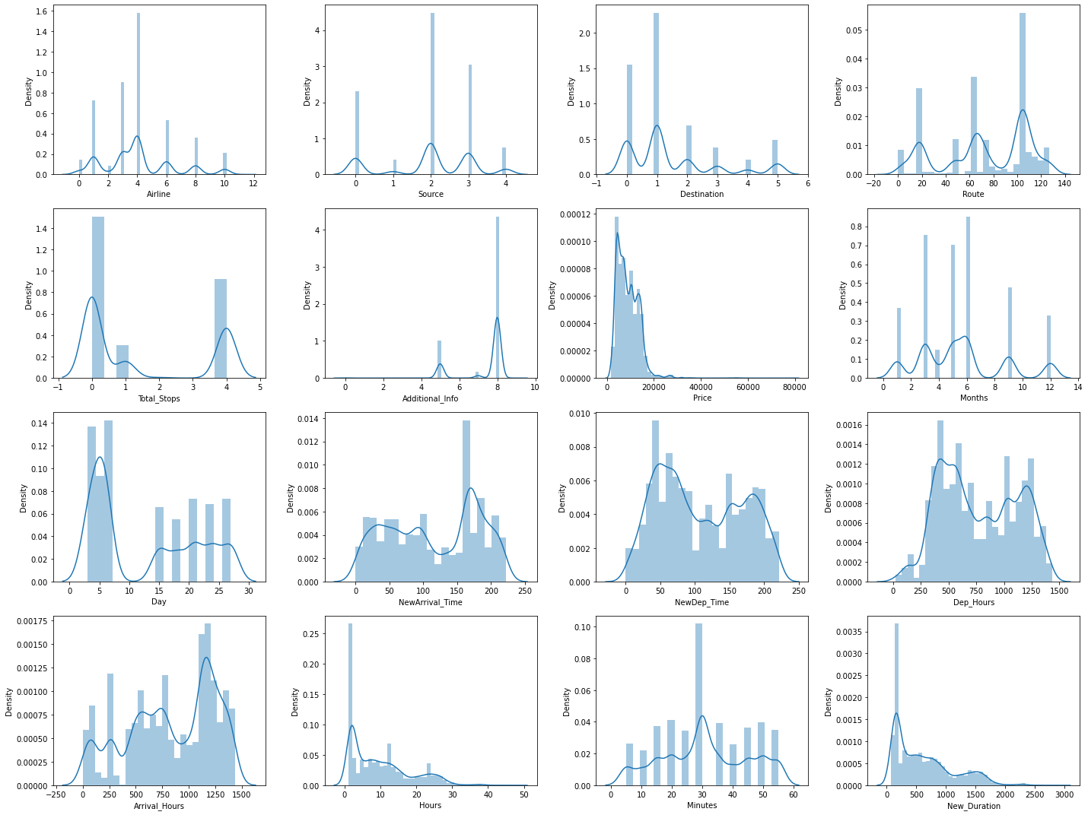
We done analysis and we found it is regression problem so we apply regression algorithm. But we build our model we split our data set into feature and target columns. After splitting we standardize our data for this we apply Standard Scaler it is present in seaborn library we import from their preprocessing module. Now we split data into train and test we keep 25% data for test and 75% for training purpose.
Model building we use ensemble bagging algorithm. We apply bagging on Decision Tree Regressor, Linear Regressor, KNeighbors Regressor, Random Forest Regressor, and XGBoost. And for evaluating the model we use R2 score and MSE. We build model and then evaluate it we come up XGBoost is our best model with 87% score. So we do hyperparameter tuning on it. After hyperparameter tuning score increase to 88%. So we save our model into pickle file. Finally we conclude this flights price problem we use regression algorithm for predicting price.

